Pedigree for Midas x Char 2009 & Atlas x Char 2008 Litter
Great Dane Fawn
Sire(2008)  MBISS CH Olympus’ Pillar of the Heavens “Atlas”  Fawn  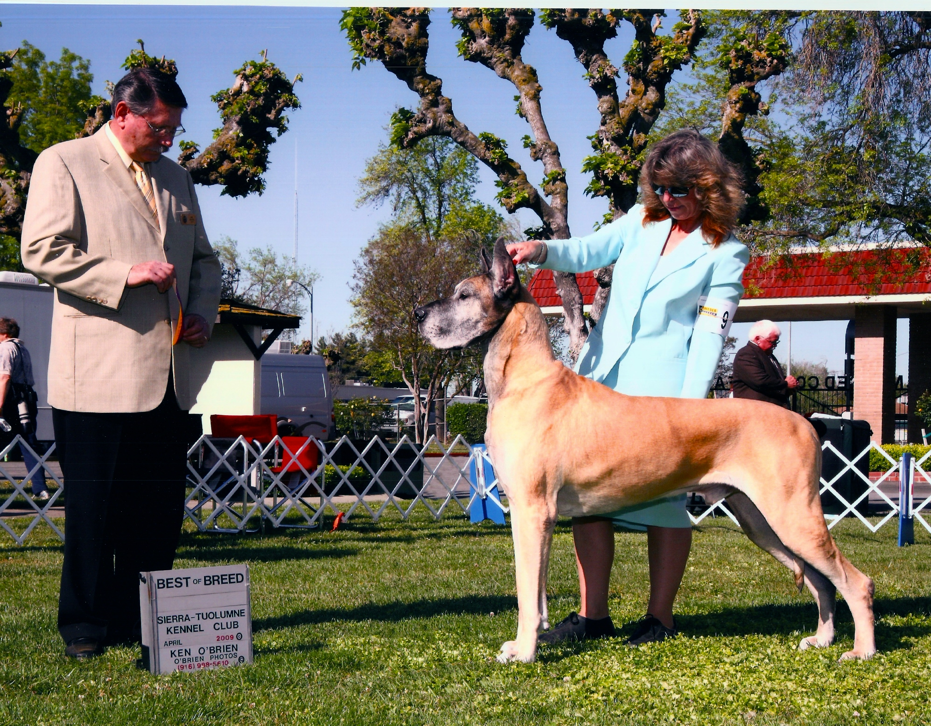  Sire(2009)  Am/Int'l CH Olympus' The Midas Touch "Midas"  Fawn  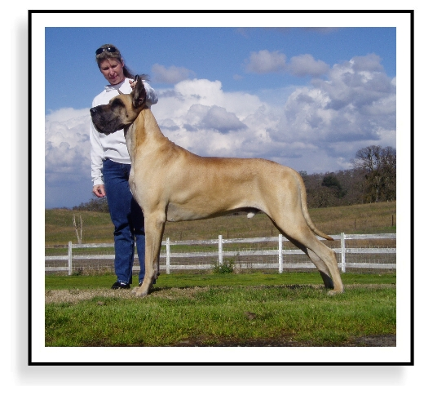 | Sire  CH Brislyn Plain Havoc V Varick "Havoc" Fawn  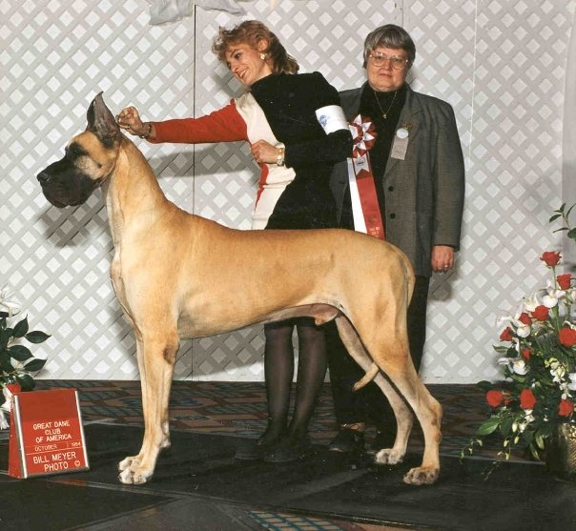 | Sire  BISS CH Hauerdane's Plain James V Rika  Fawn  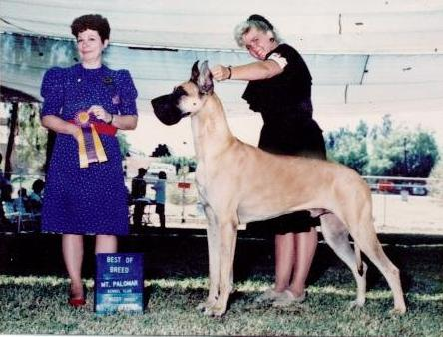 | Sire  CH Von Rasceac's French Dandy  Fawn
Dam
CH Rika's Plain Jane v Hauer ROM
Fawn
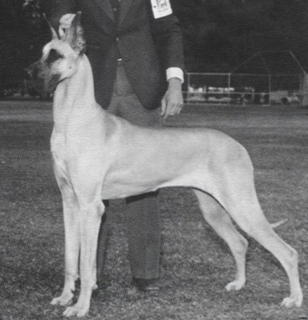

 |  | Dam  CH Varick's Maddie Hayes  Brindle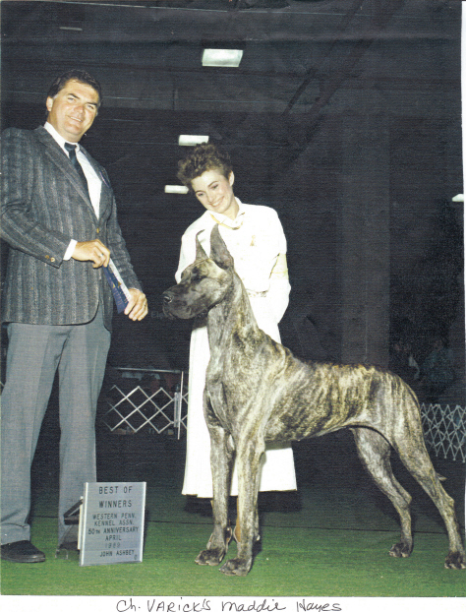 | Sire  BISS CH Honey Lane's Casablanca  Fawn  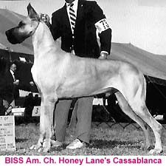
Dam
Varick's Celebrity v Brislyn
 | Dam  Int'l CH I Am The Acropolis "Aurora" Fawn  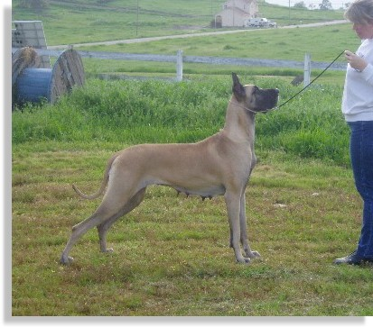 | Sire  CH Raedane's Graffiti Rika-Cyn  Brindle  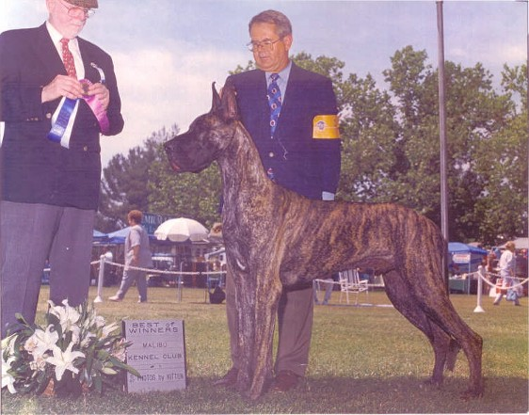 | Sire  CH Rika-Brier Indian Uprising Fawn  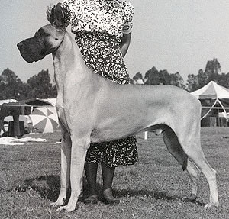
Dam
CH Loco Hills Yipes I'm Striped
Brindle
 |  | Dam  Angel Oak's White Diamond  Fawn  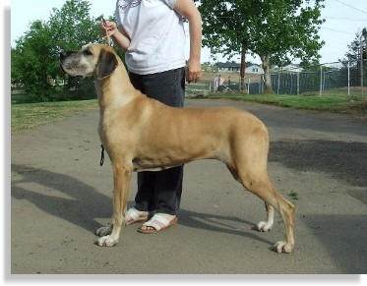 | Sire  Cloudnine Beretta Wvr Farhill  Brindle
Dam
Cloudnine's Turn'r Loose
Fawn
Dam  AKC/UKC CH Danosaurs Charlotte V WCK, CGC "Char"  Fawn  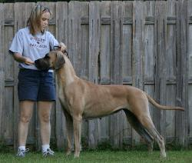 | Sire  A/C CH Sasdania's Higherground "Halston" Fawn  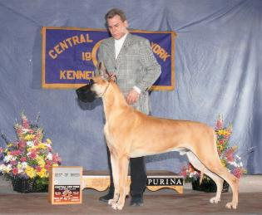 | Sire  A/C CH Sandale Wyne Talk the Talk  Fawn  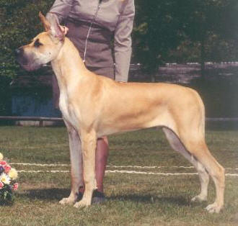 | Sire  Sandale's Had To Be You  Fawn
Dam
CH Wyne AQchaney Your One T'Talk
Fawn
 |  | Dam  CH Sasdania's Caribbean Queen  Fawn  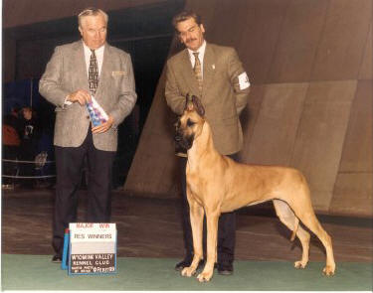 | Sire  BISS AM CAN CH Sasdania's Laissez-Faire  Fawn  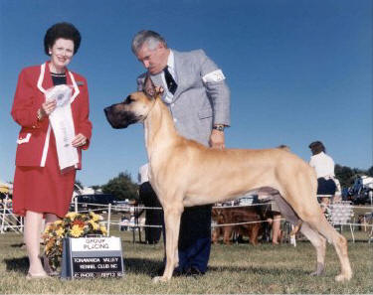
Dam
AM CAN CH Sasdania's Covergirl
Fawn
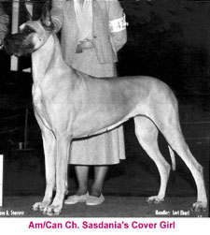
 | Dam  Danosaurs Lookin For Trouble "Anya"  Fawn  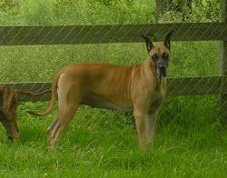 | Sire  Oliver Du Domaine De Sultan (FRA)  Fawn | Sire  Mao De Mazon Rolles (FRA)  Brindle  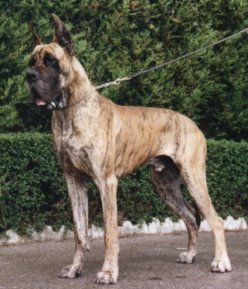
 |  | Sire  Oliver Du Domaine De Sultan (FRA)  Fawn | Dam  Leila Des Terres De La Rairie (FRA)  Fawn  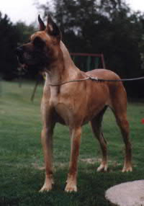
 |  | Dam  Danosaur's Belle Marin Landes  Brindle | Sire  Vicsons Marissa Moses  Brindle
 |  | Dam  Danosaur's Belle Marin Landes  Brindle | Dam  Kernerdanes Idalis of Moser  Brindle

This pedigree page was built for free at SitStay.com | Get your Dog Supplies at SitStay.com

